Latton Parish Council
(including the hamlets of Eysey and Water Eaton)

Parish Clerk: Tara Cozens

Telephone: 07460420646 Email: clerk@latton-pc.gov.uk Website:www.latton-pc.gov.uk

PARISH COUNCIL MEETING
to be held on Tuesday 1 October 2024
in Latton Village Hall
at 7.30pm

Councillors:

Cllr J Towner - Chairman | Cllr D Lloyd - Vice Chairman | Cllr R De’witt
Cllr K Johnson | Cllr R Mitchell

Members of Latton Parish Council as listed above are summoned to attend a meeting of the Parish Council for the purpose of transacting the following business.

Tara Cozens

Tara Cozens Date: 30 September 2024
Clerk to the Council

Public and Councillor Question Time – to receive questions from the public (limited to ten minutes) and Councillors (limited to five minutes) on items not on the agenda. Every attempt will be made to give accurate answers to all questions. However, on some subject’s further research and consultation with the appropriate bodies may be necessary, following which a response will be offered as soon as is possible.

A G E N D A

1. | Apologies for Absence  To RECEIVE and ACCEPT apologies for absence
2. | Declarations of Interest & Dispensations  Members to DECLARE any interest they may have for any item on the agenda, no later than when the item is reached. In accordance with the Code of Conduct issued in accordance with the Localism Act 2011, as adopted by this Council  To NOTE any dispensations received prior to the meeting in respect of this agenda
3. | Chairman’s Announcements  To RECEIVE any relevant information from the Chairman
4. | Minutes  To NOTE the Minutes of the Parish meeting held on 30 July 2024 are not ready for approval
5. | Resignation of Parish Clerk  To NOTE and discuss the resignation of the parish clerk and actions required
6. | Clerks Report  None available. See agenda item 5
7. | Down Ampney Estate  To NOTE and CONSIDER the results from the survey undertaken during August and September 2024.
8. | Councillor Updates - To RECEIVE updates from representatives:
  Area Board – Cllr Towner - meeting held 26 June 2024
  Latton Parish Community Trust – Cllr Mitchell
  Local Highways & Footpath Improvement Group – Cllr Lloyd
  The next meeting is 11th September and will be a virtual meeting
  Operational Flood Working Group North – A virtual/attended meeting was held 11 July
  Minutes of May meeting - as attached
  RWB&C Community Safety Forum – Virtual meetings were held on 14th June and 12 July - Notes attached. Next virtual meeting to be held on 9 August
  Speed Indication Device (SID) – Cllr De’witt
  Speedwatch & Lorry Watch – Cllr Johnson
 | Date of the next meeting: 26 November 2024

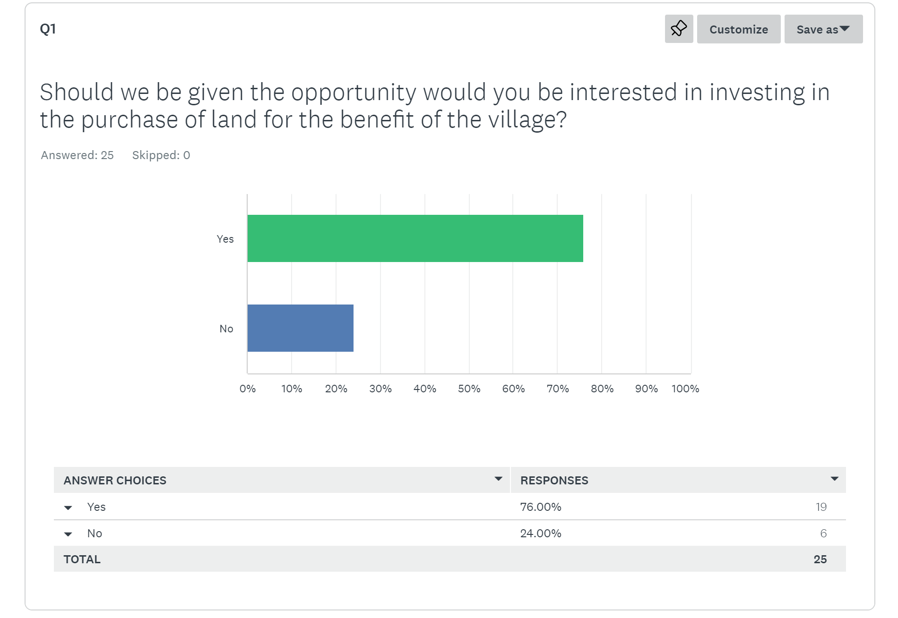
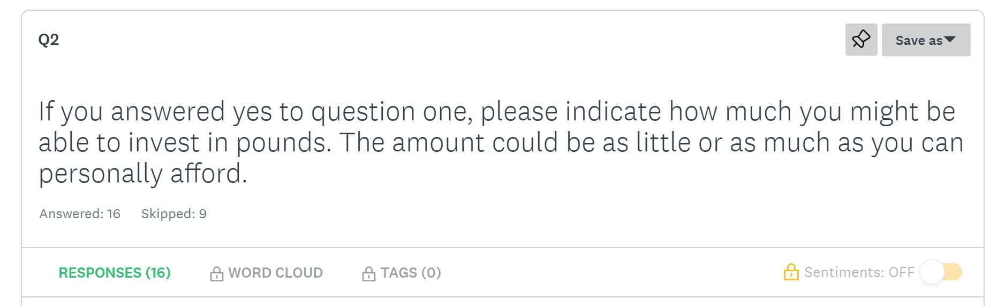

The total value indicated by respondents was between £50,000 and £80,000 depending on the exact land being purchased. For example, £50,000 was available from one respondent if the land is that in the centre of the village running alongside Gosditch.

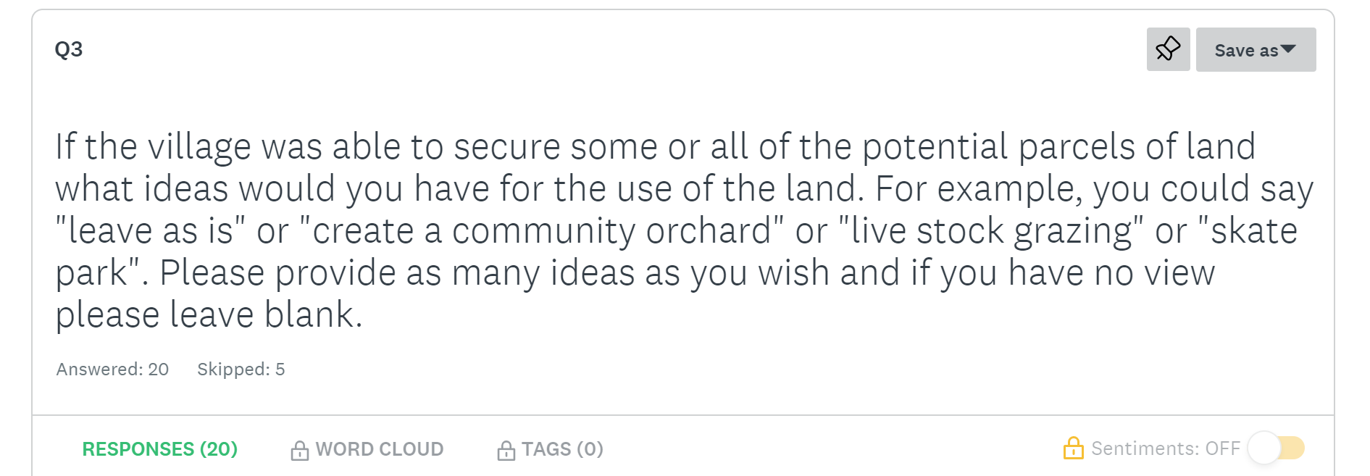

There was a range of answers to this question with the majority being “leave as is” or “some form of community use, e.g. an orchard”.

